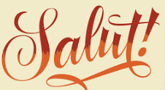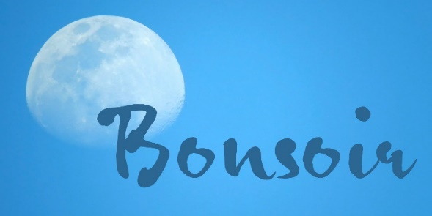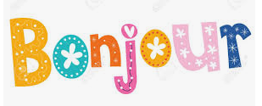

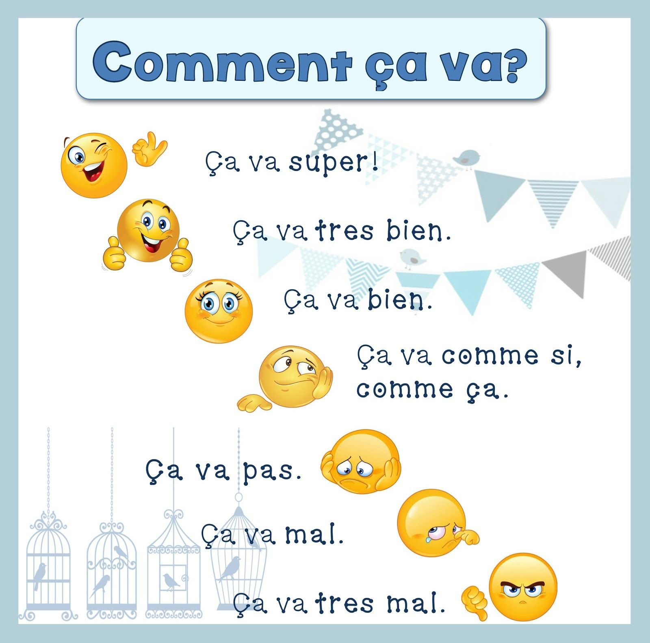

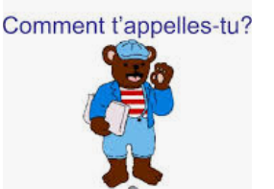





**(e)**

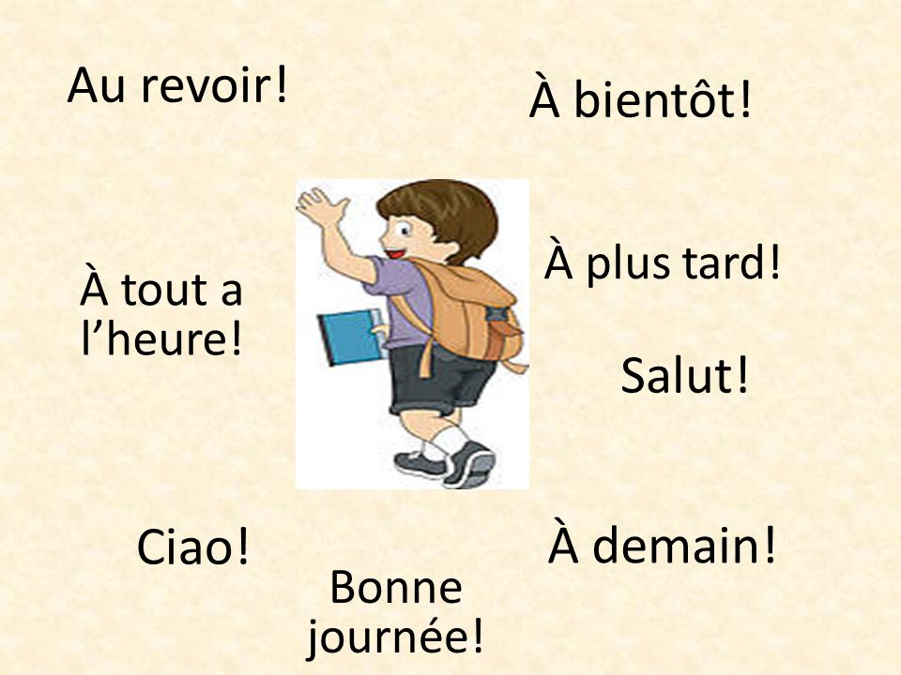

Au revoir – Goodbye (until we see each other again)

Salut – Hello or goodbye

Ciao – Ciao (like in Italian)

Bonne journée – Have a good day

À demain – Until tomorrow

À plus tard – Until later

À bientôt – Until soon

À tout le heure – Until very soon